**Understanding client request/Project Brief**

**Helios Design:**

**Company Profile/description of the client: Who is funding this project.**

The company’s name is The Green Foundation. This company was founded in August 2005 and is a nonprofit organization that aims to uplift rural communities with the support of environmental projects. They have assisted 45 rural communities in South Africa, Botswana and Zambia and planted over 30,000 trees.

The project is mainly being funded by the general public, 75% of the funding coming from corporate sponsorship and internal profit generation such as fundraising activities and sale of merchandise. 15% of their funding comes from other businesses and having a website will strengthen their focus on corporate sponsorship.

**Project description – What is being asked of this project?**

They want the general user to engage in the following activities on the website:

* Donate online
* Subscribe to their newsletter
* Subscribe to their blog RSS feed
* Link to follow them on social media channels like twitter and Facebook
* Purchase merchandise
* Contribute blog comments
* Download resources on “going green”

The major objectives for the website are to:

* Create awareness about their organization
* Generate donations and merchandise sales
* Build an online community
* Build a repository for resources and materials on “going green”
* Advertise uniqueness of organization to partners, volunteers and the media

**Technical requirements – How, what and which platform is this targeting? Is there any user research if then so which age, gender group etc.**

The Helios Design project target Media as their main platform. Featuring in a variety of local magazines and radio stations. They would like the website to attract further positive media attention and enable interested parties to download their press kits. They want links on their website to their social media to encourage people to join their community

They wish for their website to help them gather more partners in order to strengthen their network; attract employees and job applications to strengthen their efforts to increase the quality of life in the rural areas; photographers, and design students

**Project budget – Did the client put in the budget for this project.**

They don’t have a budget.

**Project timeline and deadlines – When is the project due to be completed?**

They want the bids for the design to be submitted by January 15th, 2011.

Will choose a supplier within one week of receiving the bids. The project will commence on the 26th January 2011.

Target launch is 01 May 2011.

**Design specification – Are there any design specifications required by the client?**

They want the design to be clean and organic-looking and are looking at green for the dominant hue.

The home page design should tie in with their main message, which is:

“Uplifting communities through environmental projects”

They are looking for an affordable and reliable hosting solution. We require 50MB of disk space and up to 10 GB monthly traffic, excluding email hosting.

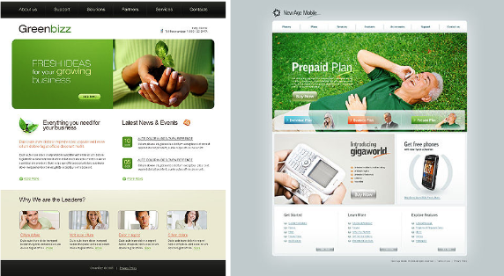

**Reference website:**

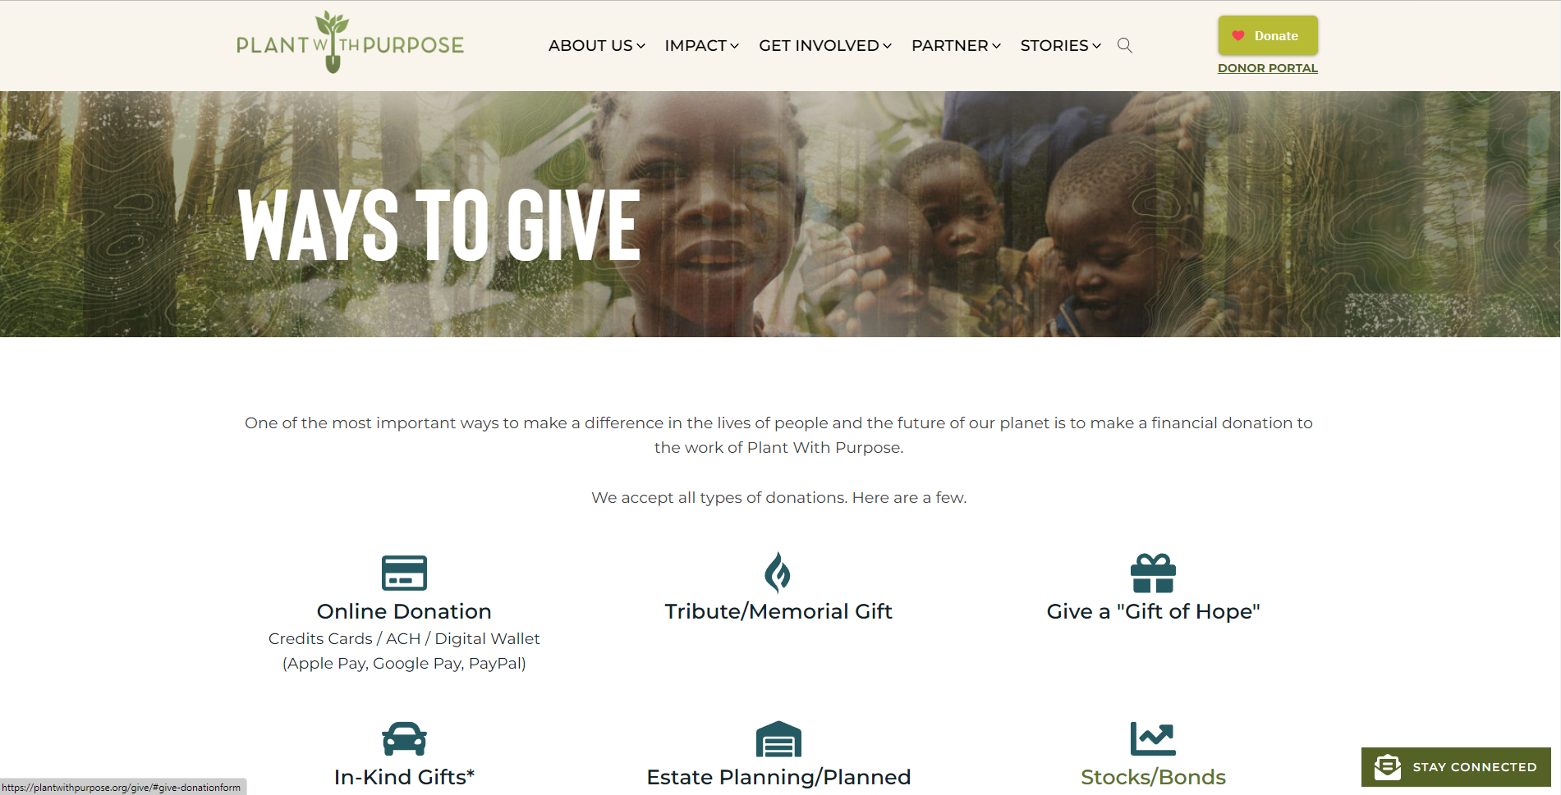

<https://www.plantwithpurpose.org/donate>

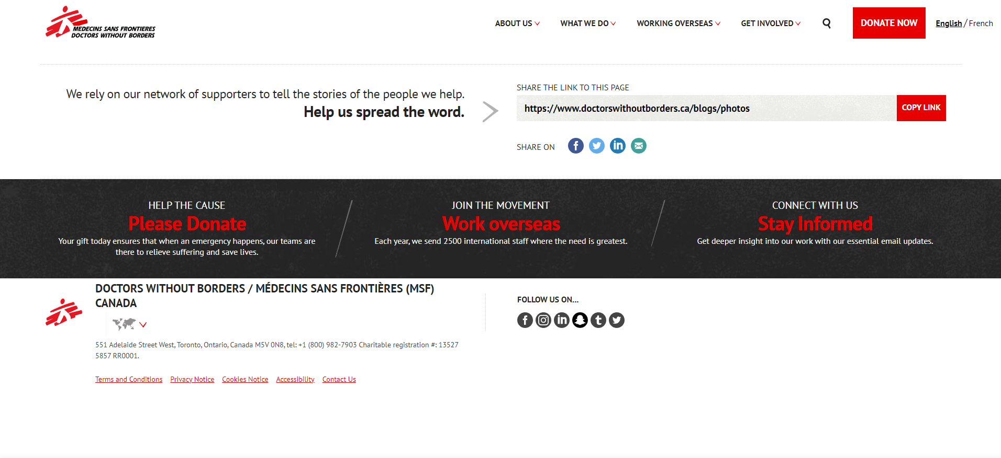

<http://msf.ca/blogs/photos/>

**Type of SDLC that can be used:**

Rapid Application Development method as it take minimum planning and can focus more on building the features requested and focus on an adaptive process.

**Nike Air Force 1s**

**Company Profile/description of the client: Who is funding this project.**

Nike is a household name in the world of sporting goods. They have stores in many countries worldwide and their main competitors are Adidas, New Balance and Puma. They keep in front of the competitors by using athletes to promote their brand.

**Project description – What is being asked of this project?**

They want their desired brand image to appeal more to its target audience and appeal to a wider demographic such as parents and grandparents. They want to become the very definition of sports itself.

**Technical requirements – How, what and which platform is this targeting? Is there any user research if then so which age, gender group etc.**

Nike’s target audience is men and women aged 18-30 with their socio-economic status being “AB, and middle to upper middle class. Nike targets athletes and people who live casual lifestyles and care about how they look and what other people think of them. They are aiming to enhance their sustainability efforts to appeal to modern customers, their three components for sustainability are: rejecting toxins, slashing water use, and reducing waste. They wish for their consumers to think of Nike as a green company.

**Project budget – Did the client put in the budget for this project.**

No budget mentioned.

**Project timeline and deadlines – When is the project due to be completed?**

No timeline or deadline.

**Design specification – Are there any design specifications required by the client?**

They want their factories to be friendly to their employees. Have their shoes be made of materials that would make it easy to recycle them.

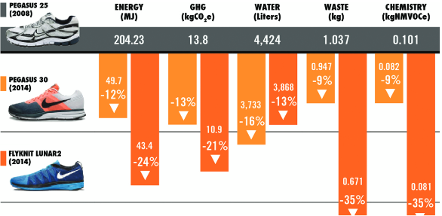

**Competitor’s websites:**

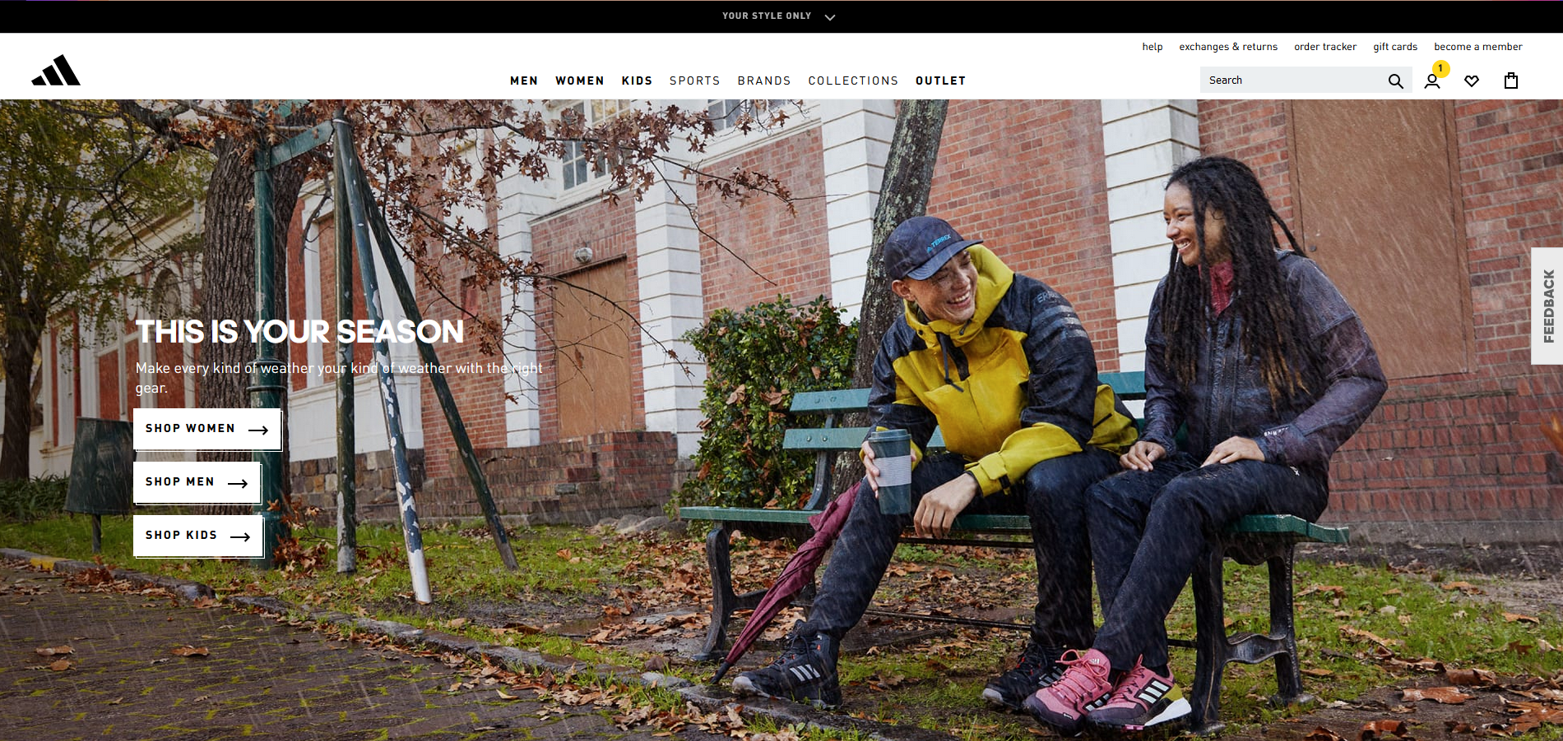

<https://www.adidas.co.uk/>

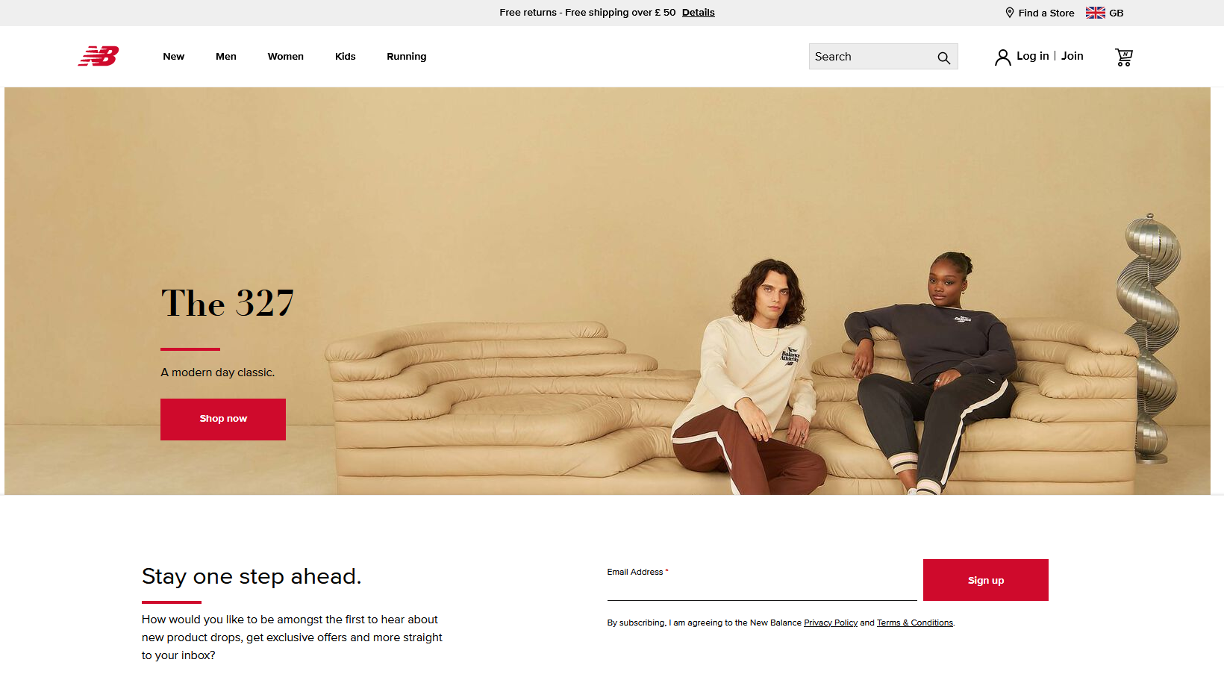

<https://www.newbalance.co.uk/>

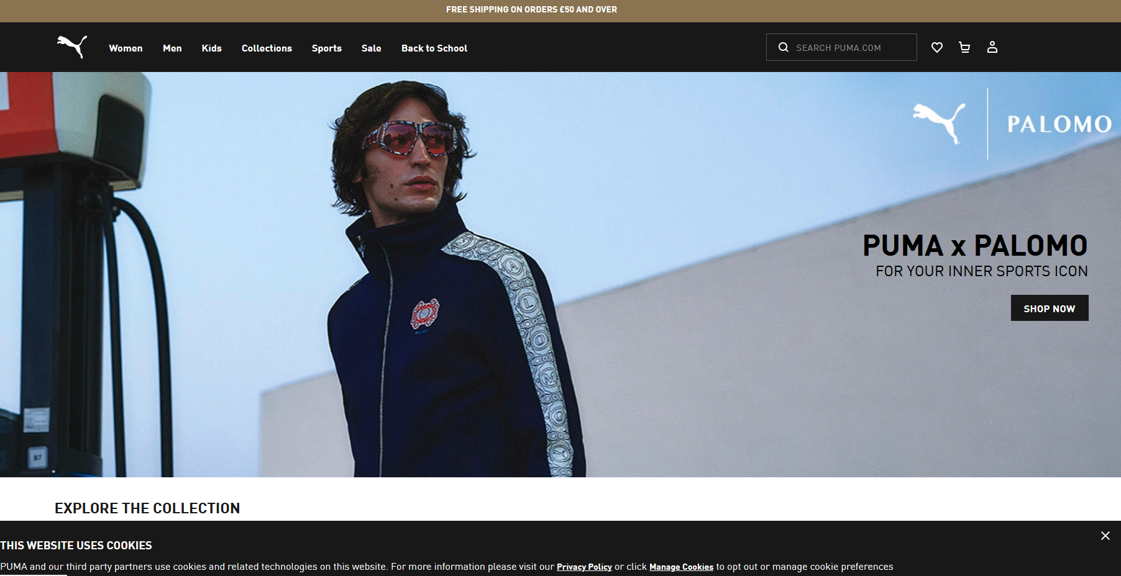

<https://uk.puma.com/uk/en>

**Type of SDLC that can be used:**

Agile method because they can keep going back to step one and try different stuff to reach their goal.

**Where’s Fluffy? Smartphone app**

**Company Profile/description of the client: Who is funding this project.**

Pet Rescue is the client. Their objective is to help pet owners keep animals safe, when a dog or a cat goes missing, Pet Rescue helps distribute information to the community and runs a search committee to help find the lost animals and return safely to their owners.

**Project description – What is being asked of this project?**

They want to develop an app that will provide pet owners with a tool to help them find lost pets. The app would let people post details of the lost pet to allow other people to see it and give information on it.

**Technical requirements – How, what and which platform is this targeting? Is there any user research if then so which age, gender group etc.**

They are targeting their app to work on Android phones, iPhone, and iPod Touch.

The main target audience is pet owners, but they also want to encourage all people to use the app to help pet owners who have lost their pet to find them and give information if they have any.

**Project budget – Did the client put in the budget for this project.**

No budget specified.

**Project timeline and deadlines – When is the project due to be completed?**

No timeline or deadline specified.

**Design specification – Are there any design specifications required by the client?**

Helpful, simple, friendly, sympathetic.

To be able to create a Lost Pet profile including photo, name, lost date and location, breed, owner phone number, etc.

**Example of designs:**

[Adopt an Elephant | WWF](https://support.wwf.org.uk/adopt-an-elephant?pc=AVN014006&gclid=96f053296d82195b0b76300910437af7&gclsrc=3p.ds&ds_rl=1262365&msclkid=96f053296d82195b0b76300910437af7&utm_source=bing&utm_medium=cpc&utm_campaign=MK_WWF_Bing%20Paid_FR_A_BAUF_Generic%20Search_All_Elephant&utm_term=https%3A%2F%2Fsupport.wwf.org.uk%2Fadopt-an-elephant&utm_content=DSA)

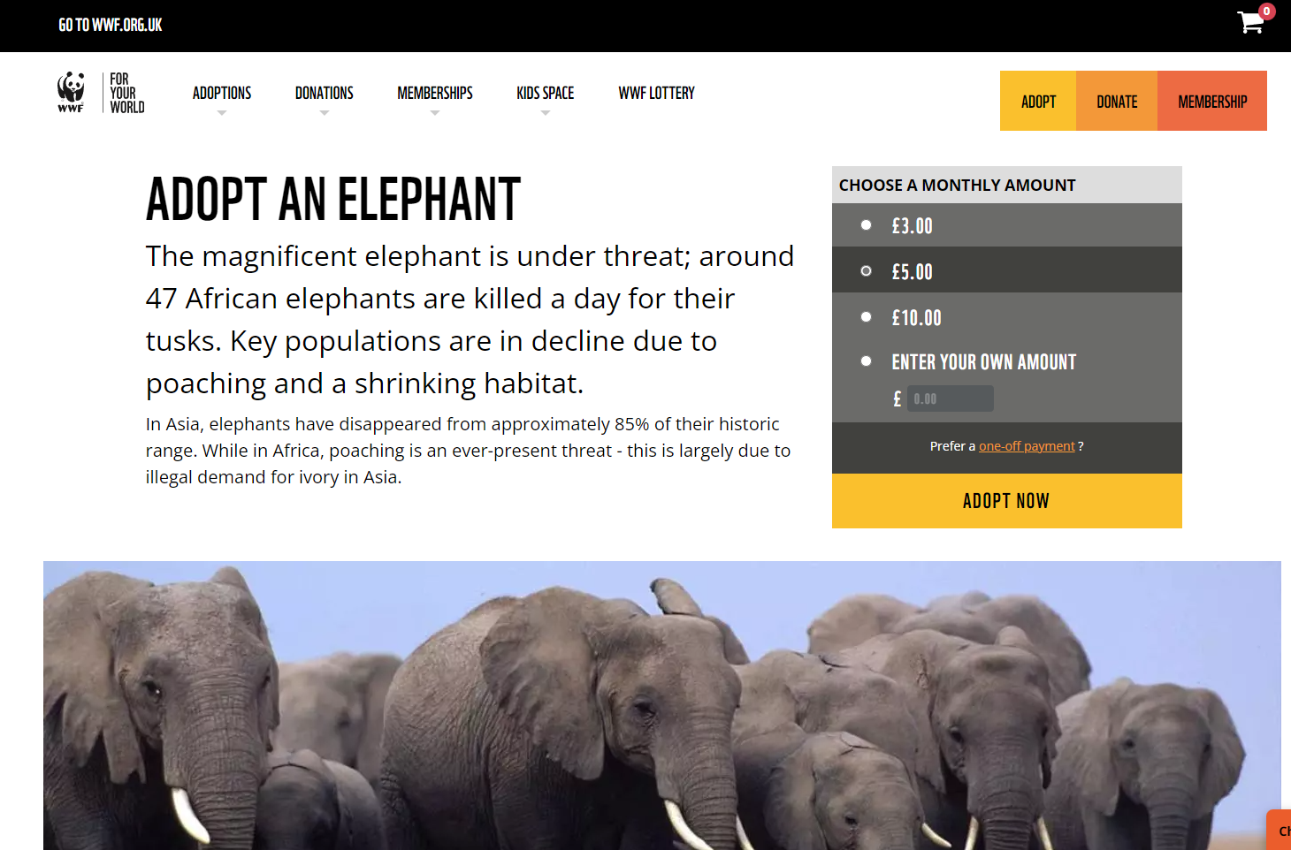

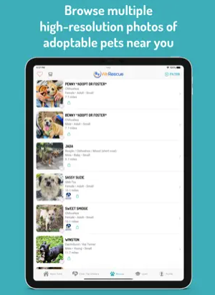

**Type of SDLC that can be used:**

Lean Development Method as they can skip unnecessary steps if they have already done websites making it faster to develop.

**Playground Reform and Upgrade Project**

**Company Profile/description of the client: Who is funding this project.**

Taylor’s University is the client of this project. They have newly-built the University’s campus, and the residential area around the campus has created an opportunity for the owners to rent out their properties to the university students. The playground is in a fairly good condition however it is abandoned due to it being small and damaged, therefore not attracting much attention.

**Project description – What is being asked of this project?**

Increase the utilization of the playground area.

Provide a safe recreational space for all ages.

Increase the attractiveness of the space.

Provide a comfortable space for rejuvenation.

**Technical requirements – How, what and which platform is this targeting? Is there any user research if then so which age, gender group etc.**

They are targeting the University students around the area as well as residents in the area.

**Project budget – Did the client put in the budget for this project.**

The total estimated cost is £32489.

The budget put in by the client is £37853.

**Project timeline and deadlines – When is the project due to be completed?**

Approval from local authority obtained by 5th August.

Project planning and design completed by 10th August.

Execution starting by 12th August.

Completion by 24th August.

**Design specification – Are there any design specifications required by the client?**

* Sharp edges and protruding objects should be protected.
* Easily accessible platform
* Falling protection
* Requirements for guardrail and barrier
* Install a drinking fountain
* Utilize existing spotlight directed onto the playground
* Create soft flooring for safety purpose
* Plant evergreen flower bed

**Design example:**

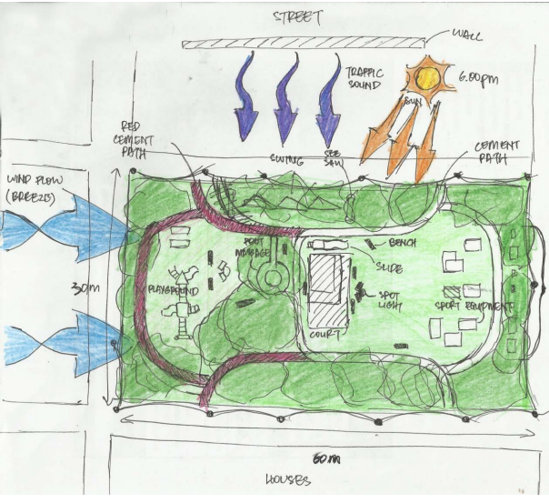

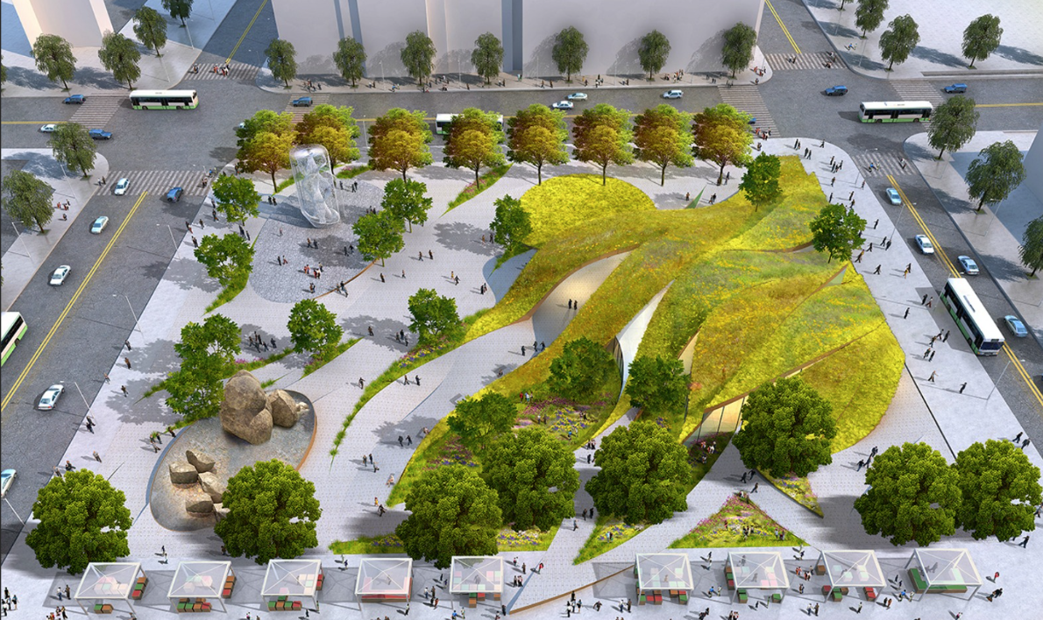

**Type of SDLC that can be used:**

Waterfall because it’s a construction so every step needs to be taken and done before they can go do the next one.